Chronic stress persecutes the body and has many detrimental long lasting effects. Chronic stress refers to any situation which is persistently stressful, meaning the stress persists for longer than a few hours. An acute stressor in contrast is one which only requires the body to mobilize a short term response. For example, suppose a hiker is walking through the forest at dusk, when he suddenly hears a low, foreboding growl coming from an overgrown shrubby area. This stressor will only require a short-term response. Once he overcomes the stressor, his body can return to a state of calm. A chronic stressor in contrast, such as seeing your parent’s divorce, produces stress over a long period of time. Chronic stress is a serious health problem as it harms the body and can even permanently change the structure of the brain.
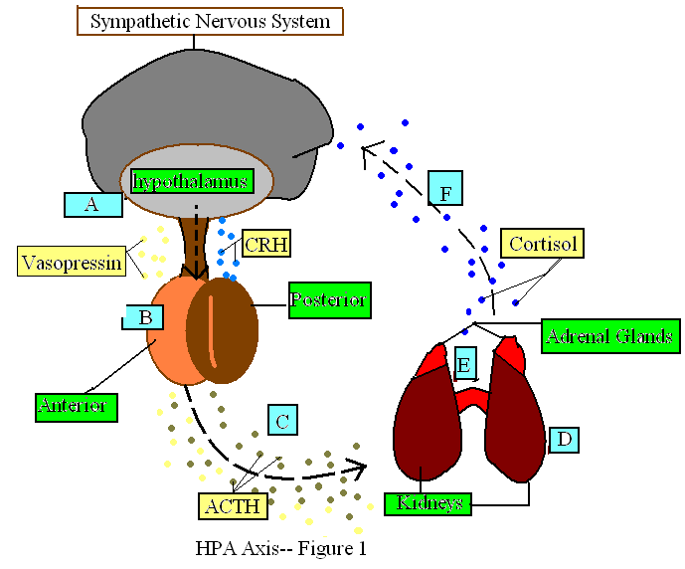
I included figure 1 because it illustrates the HPA-axis, a group of organs central to the stress response. The HPA-axis is short for the Hypothalamic-pituitary-adrenal axis. This name describes the relationship between the hypothalamus, pituitary gland, and the adrenal glands, which communicate with one another in times of stress. These organs comprise the Sympathetic Nervous System, (SNS) which is like the bodies alarm in times of arousal. In other words, it goes off whenever the individual perceives a situation as dangerous, mobilizing the body to action.
Lets return to the example of our hiker, out in the wilderness. The hiker must first interpret the ominous growl as hazardous to his life. In response to the brains perception of threat, his SNS will sound the alarm, kicking the hypothalamus into gear.
The hypothalamus [A] is a brain structure at the base of the brain. It is one of our most rudimentary brain structures, meaning it existed early in our brains evolution. The hypothalamus helps control the pituitary gland, which in turn controls many bodily functions. Once the hypothalamus has received a message from the brain, warning of danger; it releases CRH and vasopressin. CRH stands for Corticotrophin Relseasing Hormone. CRH and Vasopressin are neurotransmitters. A neurotransmitter is a chemical messenger, which travels around the brain and body, activating and deactivating various physiological systems. Vasopressin and CRH travel to the pituitary gland [B], another brain structure, positioned just slightly below the hypothalamus. I stated previously that the pituitary gland controls many bodily functions; these include thirst, hunger, sexual drive, and sleep. For this reason the pituitary gland is often referred to as the master gland. Once the CRH and vasopressin arrive at the pituitary gland, they stimulate the pituitary to produce Adrenocorticotropic hormone (ACTH). While the CRH stops at the pituitary gland, the ACTH and vasopressin travel onward [C] from the pituitary gland to the Kidneys. The vasopressin fulfills its function at the kidneys, where it induces water retention. The ACTH travels to the tip of the kidneys, where the adrenal glands [E] are found. Returning to the story of our hiker out in the woods; in a matter of moments his body has perceived a stressful situation, relayed this information to his hypothalamus, pituitary gland, and kidneys. His body has since begun retaining water. Our hiker will loose any desire to urinate and simultaneously any desire to drink water from his 32 oz. nalgene. The biggest physiological change will take place when his adrenal glands begin producing cortisol.
The adrenal glands [E] are central to the stress response. It is here that cortisol is produced. Once the ACTH arrives in the adrenal glands, they will begin producing cortisol. Cortisol is an extremely potent stress hormone, which has short-term benefits but over a long period of time is incredibly dangerous. The cortisol travels from the adrenal glands to the brain, to prepare the body for conflict. Our hiker will experience enhanced immune functioning, which will cause swelling to cease. You can imagine this would be valuable should the ominous creature in the shrubs bite our hikers leg, he will still be able to run since the swelling will not begin until the stressor is overcome. Our hiker will also experience less sensitivity to pain, and flashbulb memories. A flashbulb memory is a brief, intense, clear memory of a stressful event. This will hopefully enable our hiker to avoid similar situations in the future. With luck, our hiker should be able to overcome this stressful situation with the aid of cortisol.
As you can see in the case of the hiker, the HPA-axis can be very helpful in acutely stressful situations. However, returning to our example of a chronic stressor, you can see why this system would not be as useful for a child under the stress of parental divorce. Excessive long-term cortisol production can result in a weakened immune system, dangerously high blood pressure, and imbalances in blood sugar levels. As you have seen, the cortisol affects the brain directly, over time, this can lead to alterations in the brain. This includes an enlarged hypothalamus, which means greater receptivity to stress.

